Mathematical Object

🌟 Definition
# Source: AI Source: Provided by: [Data Path: Persons Table -> ID Column: 1, Name_En Column: Motasem Essam] -> From: [ChatGPT] on [5/29/2026]
A mathematical object is any abstract entity that is studied, defined, or used in mathematics. Mathematical objects do not have a physical existence; they exist as concepts within mathematical systems.
Mathematical objects are the "things" that mathematics investigates and reasons about.

📚 Examples of Mathematical Objects
# Source: AI Source: Provided by: [Data Path: Persons Table -> ID Column: 1, Name_En Column: Motasem Essam] -> From: [ChatGPT] on [5/29/2026]
Numbers
- 1, 2, 3
- −5
- 0
- π
- √2
Sets
- {1, 2, 3}
- {a, b, c}
Geometric Objects
- Points
- Lines
- Angles
- Triangles
- Circles
Algebraic Objects
- Variables (x, y)
- Equations
- Functions
- Matrices
- Vectors
Logical Objects
- Statements
- Propositions
- Truth values (True, False)
Discrete Objects
- Graphs
- Trees
- Networks
- Algorithms

🎯 Purpose
# Source: AI Source: Provided by: [Data Path: Persons Table -> ID Column: 1, Name_En Column: Motasem Essam] -> From: [ChatGPT] on [5/29/2026]
Mathematical objects are used to:
- Represent quantities and relationships
- Build mathematical theories
- Solve problems
- Describe patterns and structures
- Model real-world phenomena

🧩 Examples by Branch
# Source: AI Source: Provided by: [Data Path: Persons Table -> ID Column: 1, Name_En Column: Motasem Essam] -> From: [ChatGPT] on [5/29/2026]
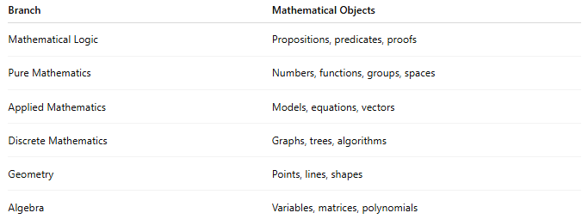
Branch | Mathematical Objects
Mathematical Logic | Propositions, predicates, proofs
Pure Mathematics | Numbers, functions, groups, spaces
Applied Mathematics | Models, equations, vectors
Discrete Mathematics | Graphs, trees, algorithms
Geometry | Points, lines, shapes
Algebra | Variables, matrices, polynomials

✏️ Example
The equation
$$x^{2}+1=0$$
contains several mathematical objects:
- Variable: x
- Number: 1
- Equation: x² + 1 = 0

🧭 Summary
# Source: AI Source: Provided by: [Data Path: Persons Table -> ID Column: 1, Name_En Column: Motasem Essam] -> From: [ChatGPT] on [5/29/2026]
A mathematical object is any abstract thing studied in mathematics, such as a number, set, function, shape, equation, graph, or proof. Mathematics is essentially the study of mathematical objects and the relationships between them.

